**ITERATING ARRAY OF OBJECTS USING LOOPS**

var obj = [

    { person: "Name 1", age: "2", company: "GUVI" },

    { person: "Name 2", age: "5", company: "GUVI geek" },

    { person: "Name 3", age: "8", company: "GUVI geek network" },

  ];

  //for loop

  console.log("for loop");

  for(let i=0;i<obj.length;i++){

      console.log(`

      Person name is ${obj[i].person}

      Age is ${obj[i].age}

      Company name is ${obj[i].company}

      `);

  }

  //for in loop

  console.log("for in")

  for(let ind in obj){

    console.log(`

    Person name is ${obj[ind].person}

    Age is ${obj[ind].age}

    Company name is ${obj[ind].company}

    `);

  }

  //for each loop

  console.log("for each");

  obj.forEach(function(value){

    console.log(`

    Person name is ${value.person}

    Age is ${value.age}

    Company name is ${value.company}

    `);

  });

  //for of loop

  console.log("for of");

  for(let ite of obj){

    console.log(`

    Person name is ${ite.person}

    Age is ${ite.age}

    Company name is ${ite.company}

    `);

  }

OUTPUT:

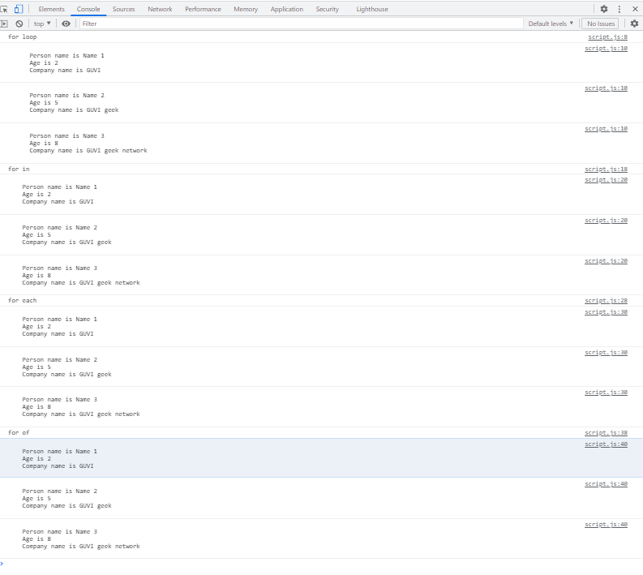

for loop

script.js:10

Person name is Name 1

Age is 2

Company name is GUVI

script.js:10

Person name is Name 2

Age is 5

Company name is GUVI geek

script.js:10

Person name is Name 3

Age is 8

Company name is GUVI geek network

script.js:18 for in

script.js:20

Person name is Name 1

Age is 2

Company name is GUVI

script.js:20

Person name is Name 2

Age is 5

Company name is GUVI geek

script.js:20

Person name is Name 3

Age is 8

Company name is GUVI geek network

script.js:28 for each

script.js:30

Person name is Name 1

Age is 2

Company name is GUVI

script.js:30

Person name is Name 2

Age is 5

Company name is GUVI geek

script.js:30

Person name is Name 3

Age is 8

Company name is GUVI geek network

script.js:38 for of

script.js:40

Person name is Name 1

Age is 2

Company name is GUVI

script.js:40

Person name is Name 2

Age is 5

Company name is GUVI geek

script.js:40

Person name is Name 3

Age is 8

Company name is GUVI geek network